MEMORANDUM
To: | Charlie Refvem, Department of Mechanical Engineering, Cal Poly SLO
 | crefvem@calpoly.edu
From: | Antonio Ventimiglia
 | ventimig@calpoly.edu
Date: | September 28th, 2025
RE: | Homework 0x00: Reading CSV Files

The results of the assignment can be seen below:
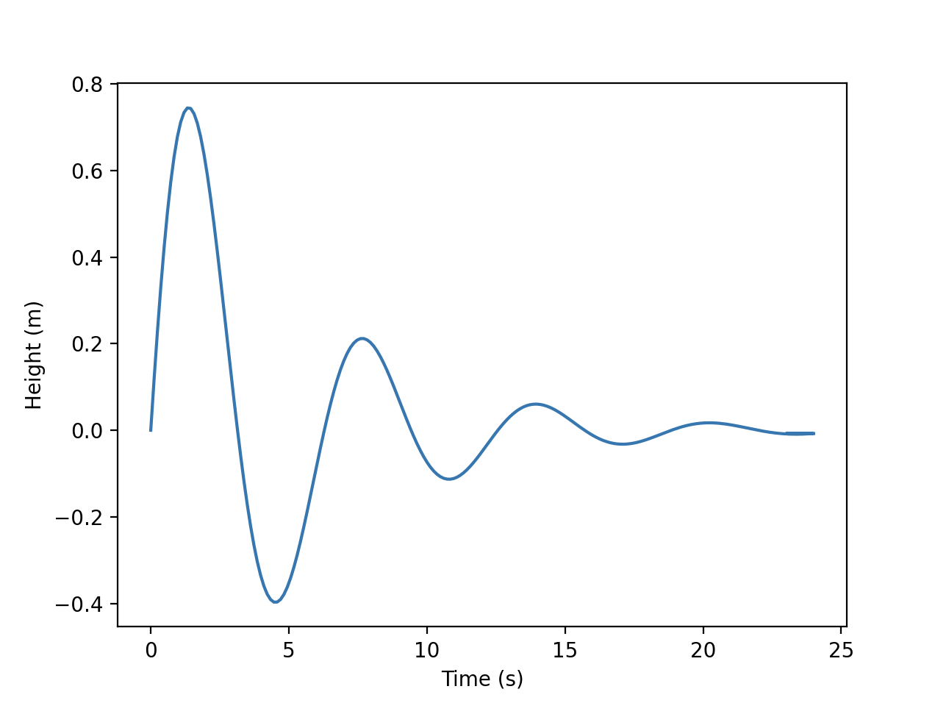
Figure 1: CSV Plot Results
The following is the console results:

Row #6 rejected. Reason: Line does not contain a minimum of two columns. Data: ""
Row #7 rejected. Reason: Line does not contain a minimum of two columns. Data: "# 0.0 0.0 0.0, 0.0"
Row #8 rejected. Reason: Line does not contain a minimum of two columns. Data: ""
Row #12 rejected. Reason: Line does not contain a minimum of two columns. Data: "waffles!!!"

from matplotlib import pyplot as plt

file_name = "data.csv"
# rejection function for printing
def rejection(row_num, reason, row_data):
print(f’Row #{row_num} rejected. Reason: {reason}. Data: “{row_data.strip()}"’)

# variable initializations
dataset_1 = []
dataset_2 = []

# open the file and read the data
try:
with open(file_name, 'r') as datafile:
for line_num, line in enumerate(datafile):
line_num += 1 # Line numbers start at 1
line_altered = line.split('#')[0].strip() # Remove end comment and strip whitespace
line_altered = [x.strip() for x in line_altered.split(',')] # Split by comma and strip whitespace
if len(line_altered) < 2: # Ensure there are exactly two headers
rejection(line_num, "Line does not contain a minimum of two columns", line)
continue # Skip to next loop
line_altered = line_altered[:2] # Keep only the first two columns
if line_num <= 1: # Skip header line
dataset_1.append(line_altered[0]) # Append first column to dataset_1
dataset_2.append(line_altered[1]) # Append second column to dataset_2
continue # Skip to next loop

try:
line_altered = [float(x) for x in line_altered] # Convert to float
except ValueError: #throw error if conversion fails
rejection(line_num, "Non-numeric data found", line)
continue # Skip to next loop

dataset_1.append(line_altered[0]) # Append first column to dataset_1
dataset_2.append(line_altered[1]) # Append second column to dataset_2
except FileNotFoundError:
print(f"Error: Could not open file {file_name}")
exit()

# Plot skipping headers
plt.plot(dataset_1[1:],dataset_2[1:])
# plt.plot([1,2,3],[1,2,3])

# Labeling the axes
if type(dataset_1[0]) != str:
plt.xlabel("1st column data")
else:
plt.xlabel(dataset_1[0])
if type(dataset_2[0]) != str:
plt.ylabel("2nd column data")
else:
plt.ylabel(dataset_2[0])
plt.show()

